**eDNA Water Filtering and Filter Extraction Protocol – Based on Goldberg et al. 2011 and personal correspondence with Goldberg**

Modified from Goldberg, C. S., Pilliod, D. S., Arkle, R. S., & Waits, L. P. (2011). Molecular detection of vertebrates in stream water: a demonstration using Rocky Mountain tailed frogs and Idaho giant salamanders. *PloS one*, *6*(7), e22746.

**DNeasy Blood & Tissue Kit – Quiagen (#69504) $155 for 100 samples**

**Water Collection Instructions**

* Collect samples in 3.8 liter high density polyethylene containers that previously contained distilled water (1 gallon distilled water jugs).
* After emptying distilled water half way fill and thoroughly rinse containers four times with stream water.
* Open container and hold as close to the bottom as possible in the middle of the stream to fill, cap under water. Wear new gloves were at each sample collection.
* Place on ice until and process or freeze within 24 hours.

**Washing Instructions**

***Protocol for cleaning filter apparatus before and between samples***

1. **Wash with dish soap and brush**
2. **Rinse with warm/hot tap water**
3. **Dip in 30% bleach solution (diluted from store bought bleach) for a few seconds**
4. **Repeat two more times (three times total)**
5. **Rinse with distilled water**

***Protocol for cleaning forceps and scissors***

1. **Wash with soap**
2. **Dip in ethanol**
3. **Use flame to burn that off and heat for perhaps 20 seconds**
4. **Rinse (partially to cool) in distilled water from tap, should observe a hiss as it cools**

***Filtering protocol***

Filter apparatus – 47 mm magnetic filter from VWR (#4242) - $221

Filters - 100 4.7 cm fine particle filters from VWR (#09-873DD) $52

**NOTE - DON’T CONTAMINATE, IT IS VERY DIFFICULT NOT DO SO, SO… follow the above washing protocols and switch gloves frequently.**

1. **Pour water into assembled filter apparatus with the suction already turned on, monitor volume in graduated flask below. Pour 250 ml at a time until desired volume has been filtered.**
2. **Turn off suction**
3. **Remove filter from filter apparatus with just flamed forceps (see above) and place on super clean wax weigh paper**
4. **Place in hood until completely dry (should take 10-15 minutes)**
5. **Cut filter in half**
6. **Store ½ in 100% ethanol in a 1.5 ml tube and label with sample name, date, and “storage”**
7. **Cut other half into at least 10-12 pieces**
8. **Place in a 1.5 ml centrifuge tube and add 360 ul ATL and 40 ul ProK**
9. **Vortex the heck out of it**
10. **Incubate at 56oC overnight (can be a little below this but must not be above as it will denature the enzyme). DON’T FORGET TO PARAFILM THE TUBE, it will evaporate overnight.**
11. **Go to step #2 below –**

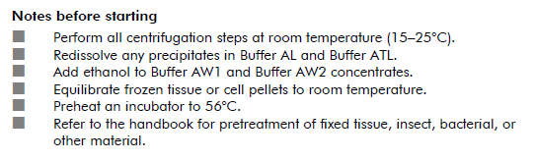

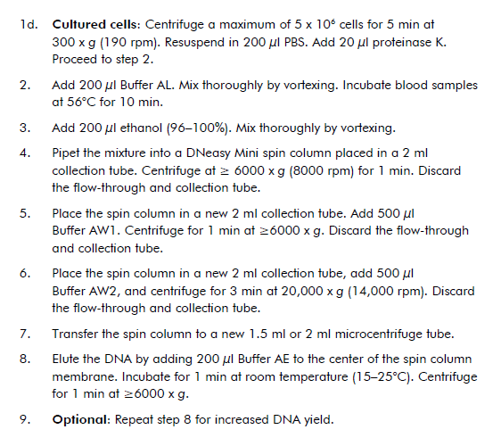

**IMPORTANT: For central KY salamander project (Ronnie, Cierla, and Trevor) – Elute once with 200 µl and then a second time with 100 µl.**

**Store DNA in carefully 1.5 ml tube at 4oC after extraction**